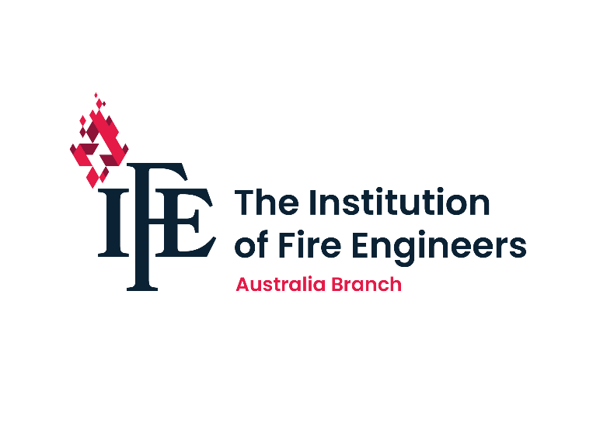

AUSTRALIA BRANCH COUNCIL NOMINEE MANIFESTO

Please write a short narrative (100-150 words) briefly describing your personal and professional background and what you hope to contribute to the Institution of Fire Engineers Australia Branch.

**(FULL NAME) Shaun Williams Member No.** 70544

**Personal and Professional History** (outline only that information relevant to IFE election)**:**

I am writing to formally introduce myself and share my background and qualifications within the fire protection industry, as well as my ongoing commitment to fire safety and compliance.  
  
I began my career as a service technician in the fire protection sector, where I developed a strong foundation in the technical aspects of fire safety systems. Through dedication and hard work, I progressed into a management role, gaining valuable experience and a deeper understanding of the industry's complexities. Throughout my career, I have maintained a strong passion for fire safety, focusing on ensuring that buildings comply with current codes and regulations.  
  
In pursuit of excellence and to enhance my capabilities within the field, I recently became a Qualified Fire Safety Assessor under the new NSW Government scheme, which mandates that all individuals issuing Annual Fire Safety Statements (AFSS) in New South Wales are fully qualified in all 36 measures. The initiative was introduced in 2020, and I undertook the necessary training to fulfill this requirement. I am proud to report that I completed my training in June 2024 and am now unrestricted and fully qualified to assess and ensure compliance within the stipulated measures.  
  
Additionally, I have been a Retained Firefighter since 2003 and am currently stationed at Glenbrook. This role has provided me with practical experience and insight into fire response and safety management, further enhancing my commitment to community safety.  
  
I am eager to leverage my expertise and experience in fire safety to contribute positively to our industry.

Refer to my Linkedin Profile for further details

https://www.linkedin.com/in/shaun-williams-j-p-gifiree-affilieaust-aa3a8865/

**What I Hope to Contribute to the IFE Australia Branch:**

With extensive experience as a manager and fire safety assessor, I firmly believe that my dedication, expertise, and skills would be invaluable assets to the branch. Throughout my career, I have consistently prioritized safety and precision in the installation and maintenance of fire protection systems. I am confident that my background will significantly enhance the branch's knowledge and capabilities in this critical area.  
  
IFE has a well-deserved reputation for excellence in the field of fire safety, and I am eager to contribute effectively to the team. I understand the importance of upholding the highest standards of fire safety practices, and I am committed to ensuring that our collective efforts not only meet but exceed those standards.  
  
My nomination is a reflection of my passion for excellence, as well as my sincere desire to make a positive impact within the IFE Australia Branch. I am dedicated to fostering a culture that emphasizes safety, professionalism, and continuous improvement. I firmly believe that my presence within the organization would elevate the branch's capabilities and contribute to maintaining a high level of safety and professionalism across all operations.  
  
Thank you for considering my nomination. I am looking forward to the opportunity to collaborate with like-minded professionals who share a commitment to fire safety and excel in their respective fields. Please feel free to reach out if you require any further information or would like to discuss my nomination in greater detail.

The IFE will be focusing on a number of key areas as detailed below in formulating our goals and initiatives for the next 3 years. Please select at least one of the following areas in which you are interested in contributing to the IFE Australia branch.

|  |  |
| --- | --- |
| **Advocacy** | **Research / Special Interest** |
| **Membership management and growth** | **Registration (CEng/IEng/EngTech)** |
| **CPD events/initiatives** | **IFE Exams** |
| **Website development** | **Marketing / Communication** |

Please complete the following matrix with detail you feel is relevant to your nomination and election to IFE Australia Branch Council.

|  |  |
| --- | --- |
| IFE Qualification/s:  (Title/Grade & Year of Attainment)  Joined IFE in 2020   * GIFireE | Professional Qualifications:  (Institution, Award & Year )   * FPAA - Qualified APFS in all 36 measures in June 2024 * CLET - Diploma Emergency Management - 2023 * CLET - Diploma WHS - 2023 * SafeGuard - Cert 3 Public Safety - 2013 * Cert 4 Training and Assessment * AffiLIEAust – Engineers Australia – 2021 * Justice of the Peace - 2022 |
| IFE Contribution (International, National, State/Territory):  (activity undertaken, positions held) | Professional/Life Experiences:  (relevant projects, roles/portfolios held)   * Operations and Compliance Manager - Equans 2020 - Current * Essential Services Manager - MDL 2017 - 2020 * Manager (Various Positions) - ARA Fire - 2008 - 2017 * Retained Firefighter - FRNSW Glenbrook 2003 - Current * RFS – Mt Riverview 1998 - 2003 |